APPLICATION OF DECIMAL TO HEXA CONVERSION

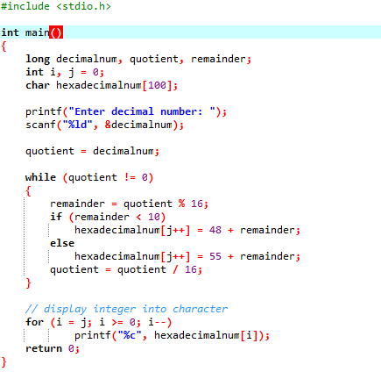

OUTPUT

